Friday May 5th : Rome - Pitigliano – Pisa - Villa

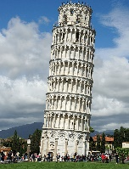
Then on to……

The number 1 visited site in Tuscany….

We have some surprises here.
Hint 1: how many leaning buildings are there?
Hint 2: what Jewish story is hidden a few meters from the tower
Hint 3: which is the third biggest Jewish community in Tuscany?
And finally….. Villa Coselli – already for our Shabbat rest

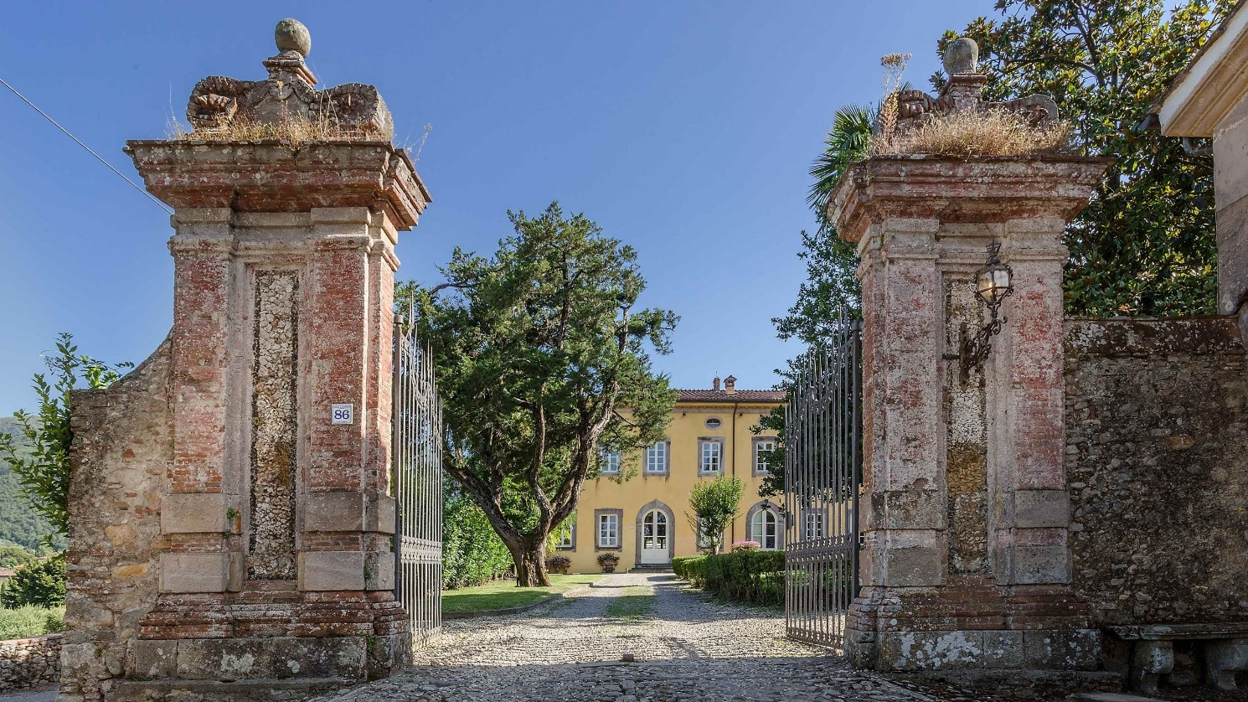

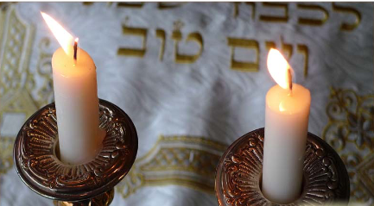
Shabbat, May 6th

Shabbat on a Naomi tour is always a little different: we push the envelope and try to include as much of a local experience as Hilchot Shabbat will allow….

Sunday, May 7th: Florence all day

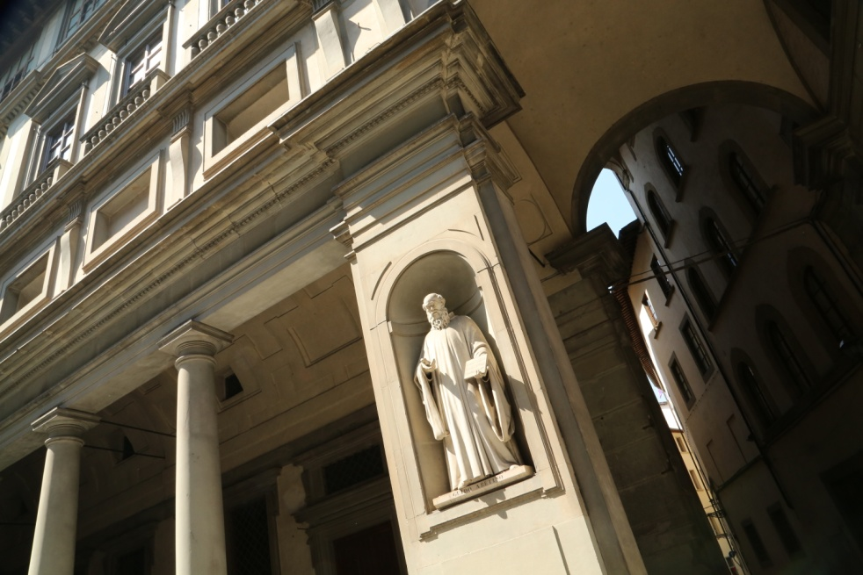
There is an option to start the day (very early) with a balloon ride over the rolling Chianti hills.

We’ll see the Statue of David, the cathedral (duomo), Piazza della Repubblica, Ponte Vecchio and visit the famous synagogue

After lunch in town, there’s time to follow your personal preferences in Florence.

If you wish to visit the Uffizi Gallery you should pre-book. Otherwise you can explore this gorgeous city in greater depth according to your interests, visiting palaces, museums and galleries, the leather market and stores.

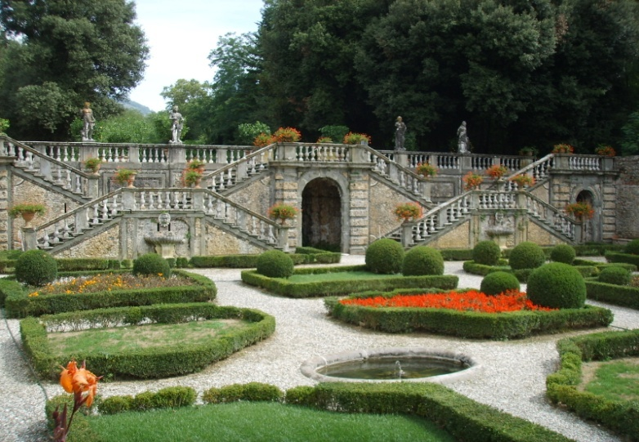
Monday, May 8th: Lucca & Region; ATV tour (optional)
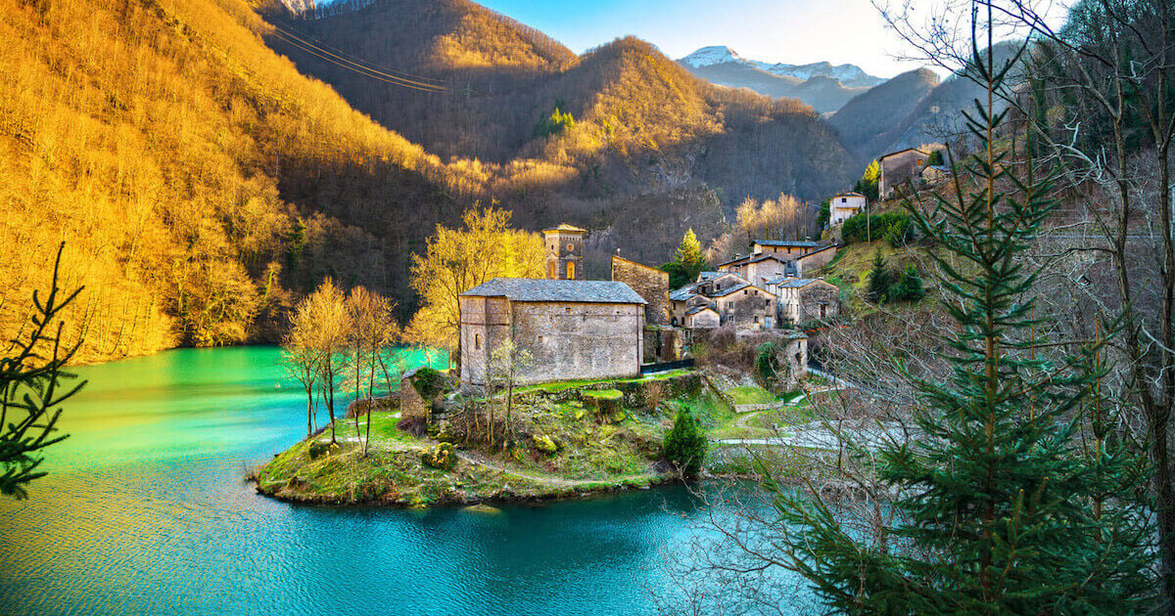
The region is famous for its aristocratic villas. Villa Torrigiani is one of the most interesting as we'll be able to tour both inside the villa and tour the gardens.

The drive to Barga will help one understand the beauty of the region. We stop to see the famous Devil’s bridge, and climb up to this medieval mountain top village where time has stood still for hundreds of years. We’ll climb the winding narrow streets to the duomo at the top of the village to breathe the clean air and enjoy the 360º panorama – the stuff of dreams!! ATV option for those looking for extreme fun!!!
Lucca – the overview – by bicycle or on foot
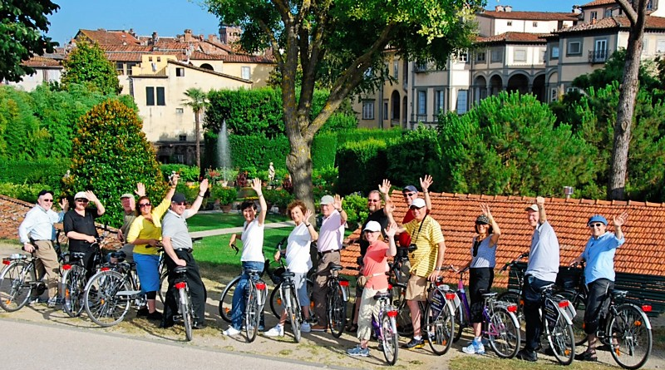
You’ll feel 16 when you bike on the wide walls and thru the town; take a stroll thru 99 piazzas or just people-watch in “our” café where the “tab” is always open
We’ll end the day with short concert of arias by Puccini, the favourite son of Lucca.

Tuesday, May 9th: Siena – Winery – San Gimignano
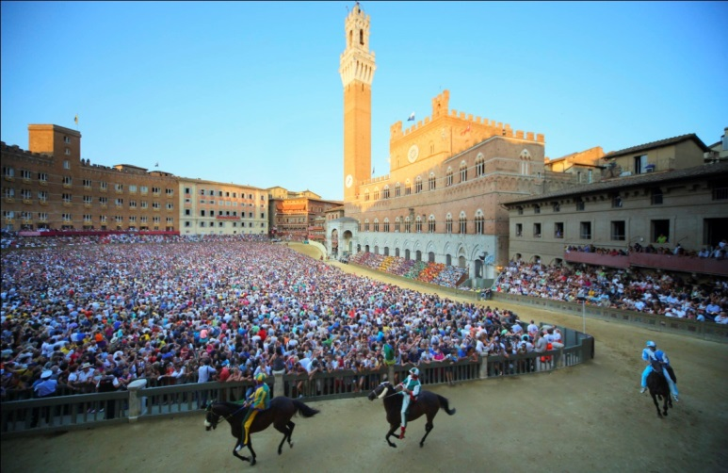
Siena

We’ll visit the famous Piazza del Campo, home of the Palio horse race, the beautiful synagogue, and, if we are lucky, meet one of the community's leaders; there is time to wander around this iconic bustling ancient city

Agriturismo & Kosher Winery

You must visit an Agriturismo – a uniquely Italian concept. This one is home to a winery which is kosher in its entirety: Terra di Seta. After a wine-tasting aperitif we’ll enjoy our lunch while looking out over the gorgeous view

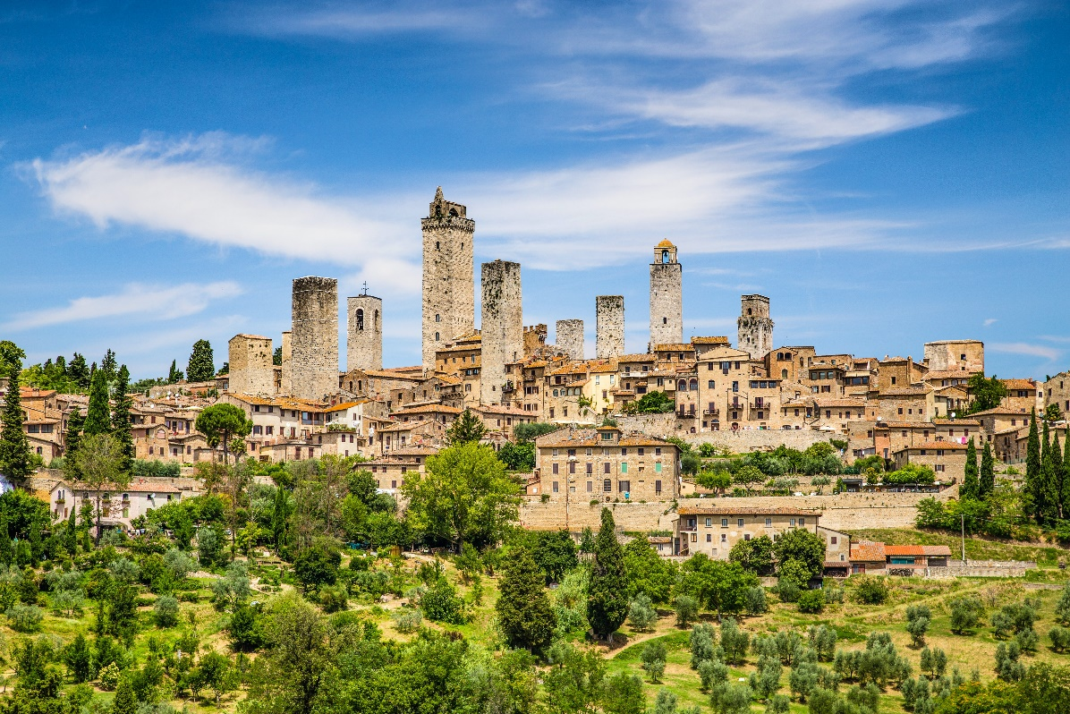
San Gimignano – the Manhattan of Tuscany

Take your time - to explore the famous city of towers, climb to the top for the incredible views, visit the stores, enjoy a coffee, take lots of photos……..

Wednesday, May 10th:
Forte dei Marmi – Hike part of the Cinque Terre trail

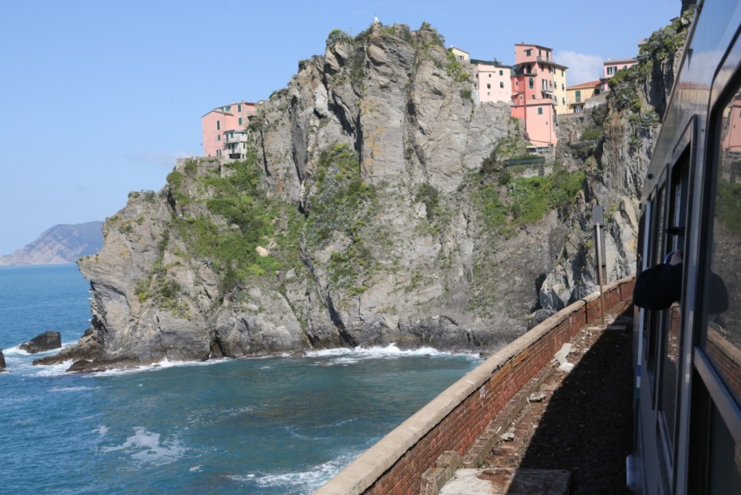
Forte dei Marmi
Tuscany’s most elegant seaside resort has a great weekly country textile market.

Hike the Cinque Terre

For years one of the highlights of this tour – a 2-hour somewhat challenging hike overlooking the sea. A bus and a train will bring us to Corniglia where we start, hiking to Vernazza and then taking a train back.

Foto Eugene Weisberg thanks

Thursday, May 11th

After breakfast, we’ll take you to Pisa airport or train station for the start of your home-bound journey.

Alternatively, you can take a taxi to Florence airport or station. Depending on where you are coming from and where you are going to, we are happy to advise you on the best way to travel.

We are always pleased to help you arrange flights and insurance. If you wish to spend time before or after the trip eg in Venice or Rome we are happy to help make the arrangements for hotels, guides and food.
FAQ
Kashrut: a mashgiach tmidi will be present; we use Glatt meat, regular approved milk and milk products, but chalav yisrael observers can be accommodated if we are notified at time of booking.
Meals: full buffet breakfast, light lunch on the move, elegant served dinnerhealthy snacks available, all drinks and wine included

Tefillot: 3 times a day; Sefer Torah

PRICE from $5950 pp
(even more DLX rooms available; single supplements $1500 if required)

not included in the prices shown
- flights: NOTE: the tour starts in Rome (FCO) and ends in Pisa (PSA); option Florence (FLR)
- optional activities, eg ATV, balloon ride over Chianti
- spending money for shopping: eg Lucca's stores are gorgeous and not overpriced as the town is not too touristy. The village markets of Tuscany are a must. Free time will be given in Siena, Florence and San Gimignano for you to choose whether to sight-see or spend!!
- upgrades: deluxe rooms (DLX), and single occupancy are available at an additional price (see booking form).
- insurance: all clients should be aware that while all efforts are made to avoid any problems before during or after your trip, Naomi carries no insurance for your health or luggage. While using the services only of registered suppliers, we recommend that you purchase fully comprehensive travel insurance as Naomi cannot be held liable for any mishaps during your stay.
- tips: we recommend $350 per person for drivers, chefs, waiters and chambermaids: we will collect and distribute for you.
IMPORTANT SUGGESTION

We strongly recommend that you come to Rome the day before the tour and stay at the Hilton Hotel inside Rome’s Fiumicino airport. The hotel offers free shuttle bus service to and from the city center where we can organize tours for you and there are several kosher restaurants.

This will help you recover from the journey and avoid any risk of your missing the start of the tour.

We cannot wait for late arrivals as it is unfair to other guests. The cost of "catching up" to the group by taxi/plane is MUCH greater than the cost of a night at the hotel!!

We will book this night for you and there will be a kosher breakfast available before leaving on the tour

Looking forward to having you with us in Tuscany!!!!
Naomi and Eric
+972 52 3860551
(9am-9pm Israel time only please!!)
www.naomitours.com
info@naomitours.com

