after the incredible success of our Provence tour last May
Naomi Boutique Kosher Tours
we are so excited to be returning to beautiful
Provence, France
Tuesday – Monday, May 30 – June 5, 2023
6 nights, 7 days
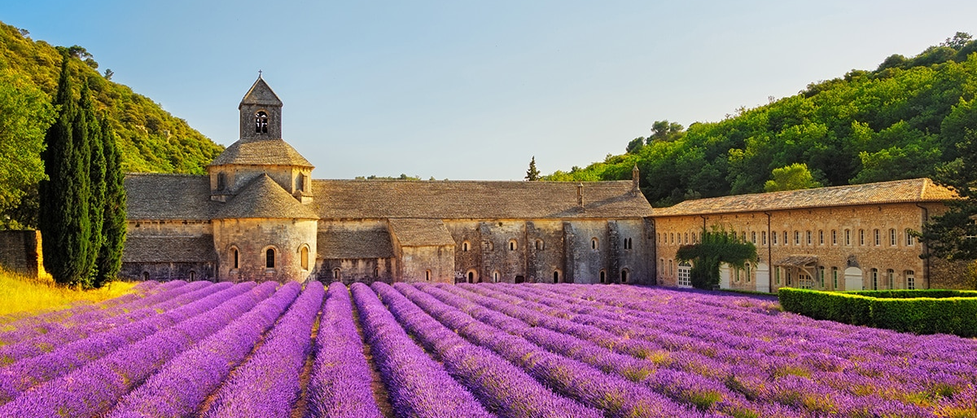
totally DLX tour staying at the same gorgeous
5* Boutique Hotel in Saint Remy
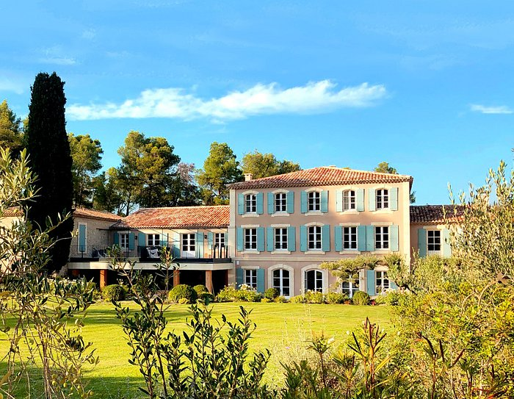
Provence means: hilltop towns, village markets, Cezanne, Van Gogh, lavender, excellent olive oil, fine cuisine and, on our tour …. unlimited fine French kosher wines!!

Day-trips: include the many Jewish and general sites of interest in the area and some of the gorgeous towns in this fabulous region of Southern France. Hiking will also be on the “menu”!!

Itinerary
Please note: the order in which we visit places might change

Tuesday May 30: Meeting point: Marseille airport: 10 am
(see below for flight recommendations) then it’s just a half-hour drive to:

Marseilles: for a drive through and lunch in one of the many kosher restaurants, followed by a boat trip in The Calanques

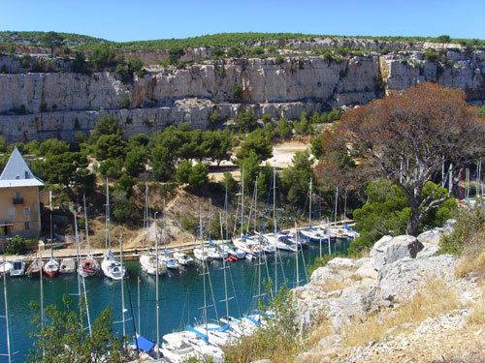
We head to Cassis, a pretty fishing village with lovely and lively harbor.

The Massif des Calanques is a wild and rugged terrain stretching from Marseille to the east towards Cassis, a series of inlets with steep walls – the French fjords!

This is one of France's great natural beauty areas and we will offer a relaxing boat ride to enjoy it.

You’ll have time to relax on the bus on the way to our hotel to enjoy Dinner!!

Wednesday May 31: Van Gogh Day
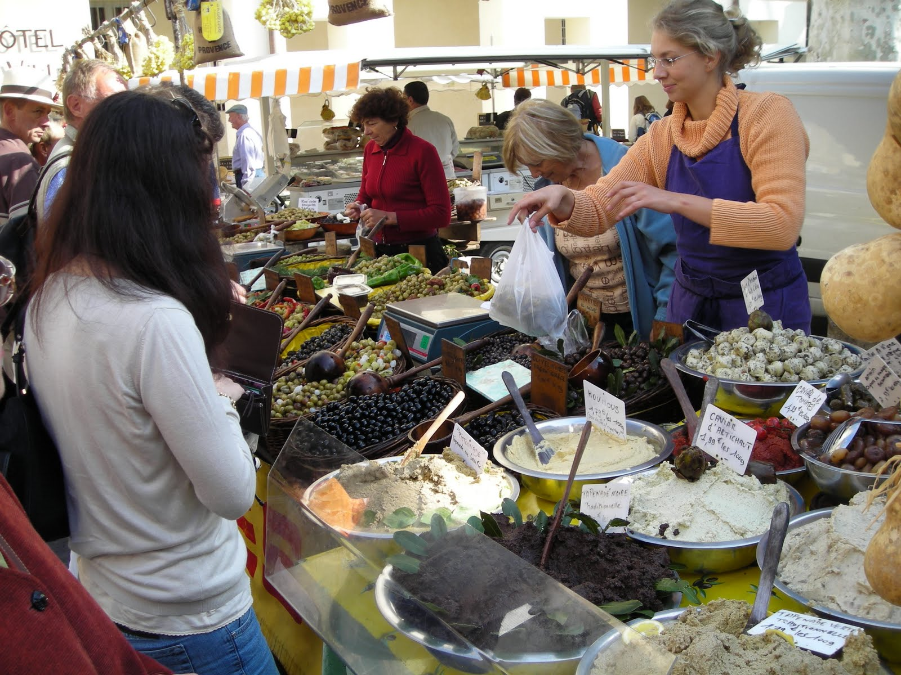
Saint Rémy de Provence: one of the "must-sees" in Provence. The main reason is Vincent Van Gogh, who produced more than 150 paintings of the countryside surrounding Saint Rémy. Many of the places painted by the artist can be rediscovered, the wild flowers, olive trees, cypresses, the Alpilles. St. Rémy has wonderfully restored town houses and lovely shops. It is the birth place of astronomer Nostradamus, of Jewish descent.

Wednesday is Market Day!!
We will also visit the institution where Van Gogh spent the last year of his manic life, now used to treat depression with art therapy.

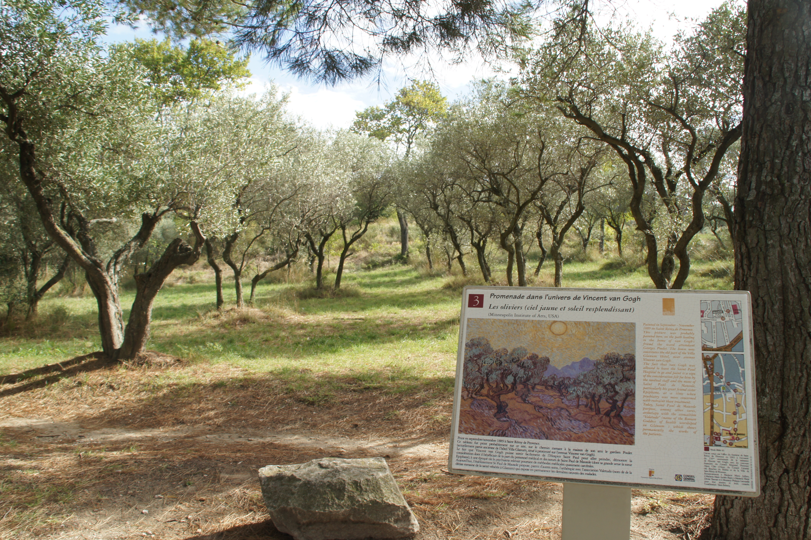

Lunch will be enjoyed in the grounds of an olive oil producer in the region.
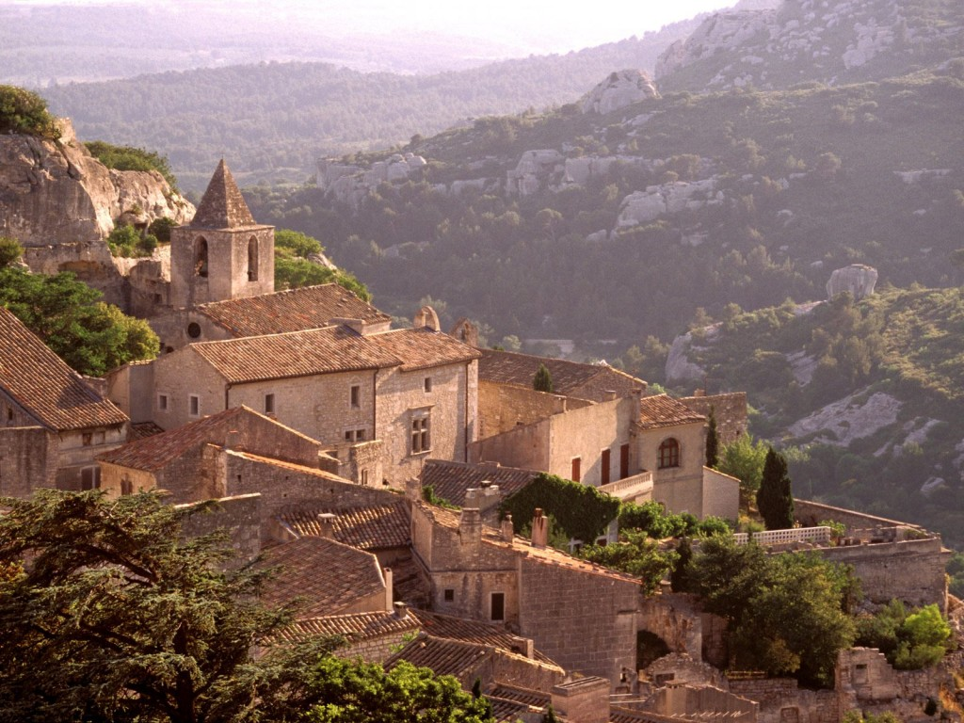
Les Baux de Provence: one of the 'most beautiful villages of France'.
The real highlight of Baux is in its great location - nestling in the Alpilles Mountains, it has great views across the plains that stretch to the south, and on to the Mediterranean beyond, as well as the attractive rocky landscape of the Alpilles themselves.

There will be time to enjoy the hotel facilities before dinner …..

Thursday June 1: Jewish Provence
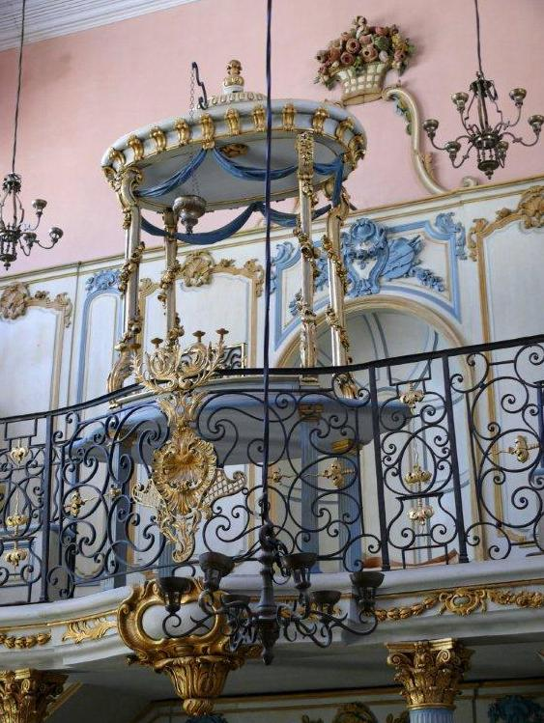
Cavaillon: visit to the Synagogue and the museum.

One of the most remarkable synagogues of Provence, the Cavaillon Synagogue, bears the hallmarks of a unique history specific to the Jews of this region. The present structure, built in 1774, features many of the extravagant decorative flourishes and color palette (including pink, gold, green and blue) of the Rococo style that was fashionable at the time.

Carpentras: France’s oldest active synagogue.

Jews lived in Carpentras since at least the 12th century, when its scholars and doctors were esteemed in all of France. The original synagogue dates from 1367 and formed the base for the reconstruction of the synagogue in the 18th century, then restored in the 1950's.
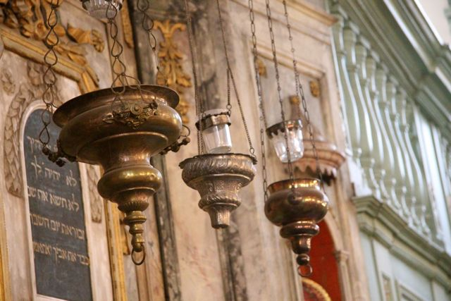
Avignon: visit to this beautiful town, famous for its bridges on the river Rhone, the Pope's palace… and the unique synagogue.
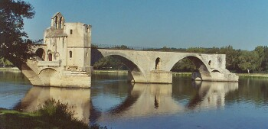
In the 14th Century, France expelled the Jews, but the Pope offered them refuge in Provence, a papal territory in the south. The Jews of Provence became known as the “Pope’s Jews” and there they lived in relative freedom, enjoying the Pope’s protection. You’ll need time to explore this city alone too… and sing the song (Sur le pont d’Avignon….)
Back to Saint Remy for dinner …..

Friday June 2: Arles, Pont du Gard and a kosher winery
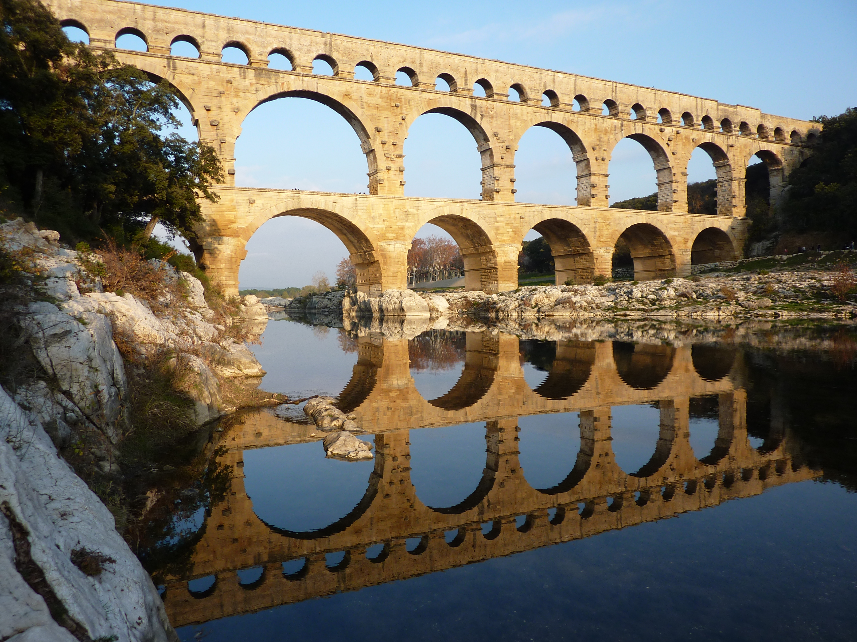
Arles: a really beautiful Provencal town, proud of its origins. It is France's largest municipality.

Above all, it is a town of the arts: it was a capital in Roman times and became a major religious centre in the Middle Ages. Van Gogh was hospitalized here and the city proudly recognizes its most famous resident.

Lunch will be in a wonderful Kosher winery followed by a visit to the incredible Roman Aqueduct at Pont du Gard.

If you wish we will offer you to go kayaking in the river, beneath the beautiful bridge but ONLY if there is enough water!!!!
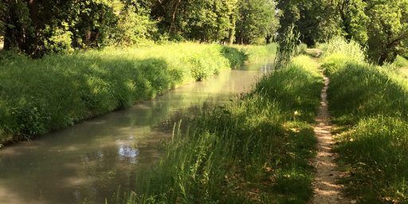
Shabbat June 3: Saint Remy

A day NOT JUST devoted to prayer, food, rest BUT ALSO a walking tour into town along the banks of the river to stretch our legs!!

Sunday June 4: Luberon day
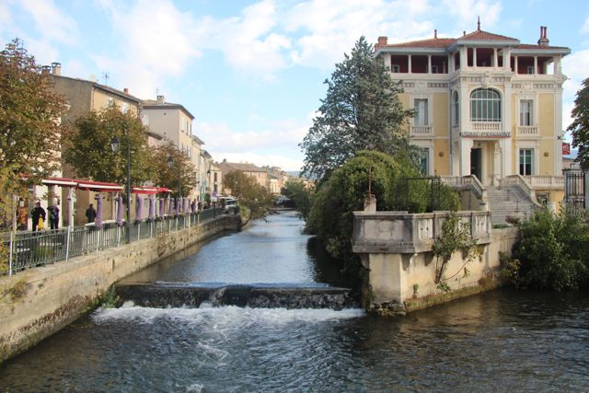
L’Isle sur la Sorgue:

Sunday is market day in this beautiful village, one of several we will visit today. This one is famous for its antiques.

Lavender is the most popular of aromatic plants known for its perfume and therapeutic virtues. We’ll visit the Lavender Museum.

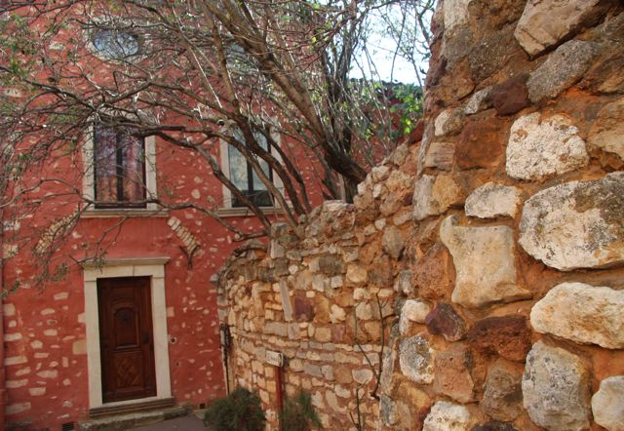
Fontaine de Vaucluse: The fame of the village is essentially due to the impressive spring which we’ll climb up to see. This gigantic water source is the most powerful in France.
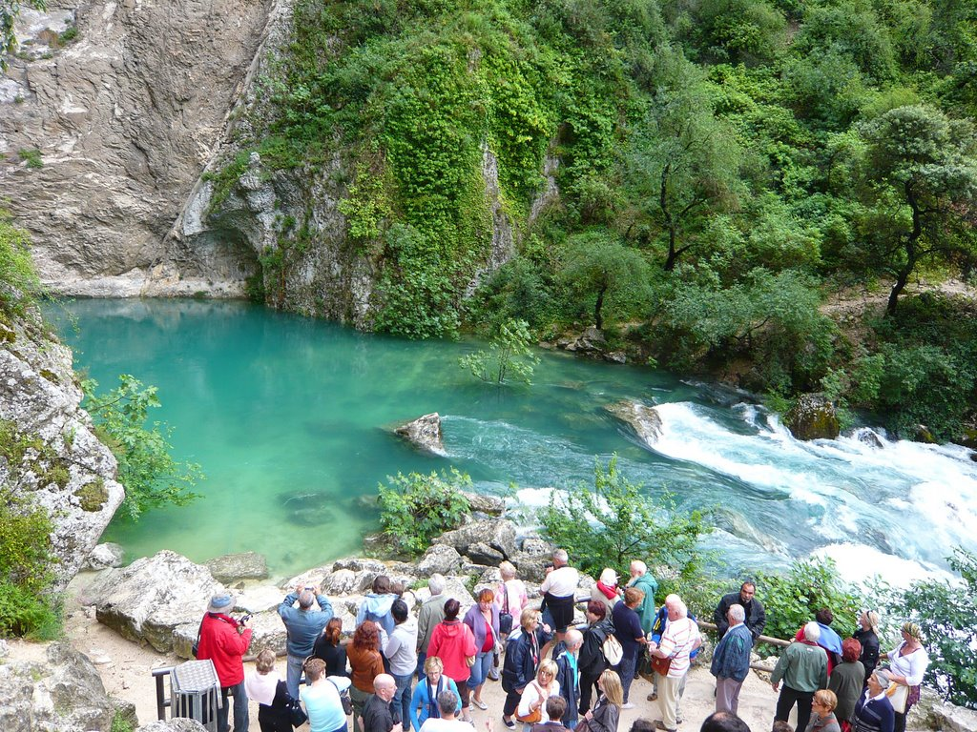
Roussillon: Situated in one of the world’s biggest ochre deposits, Roussillon is known for its magnificent red cliffs and ochre quarries. The red, yellow and brown shades of the earth form a striking contrast with the lush green pine trees. They are also the colours of the houses which makes for a magnificent town-scape.
The vivid blue of the Provençal sky and the exceptional quality of light make this a magical site.
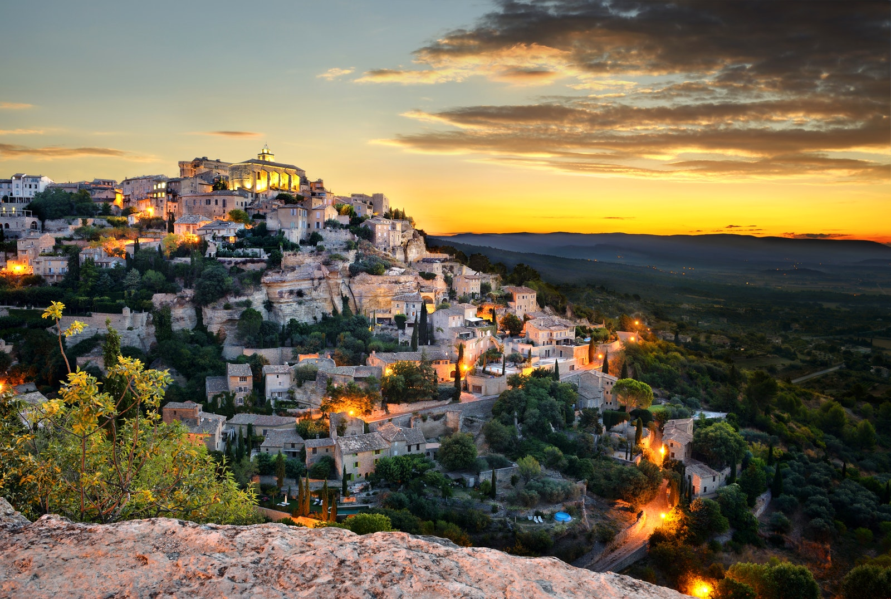
Gordes: The village has a world wide reputation due to its location on a steep hillside with magnificent views of the Luberon Valley, its famous inhabitants; and Peter Mayle's book A Year in Provence certainly helped the town become known.
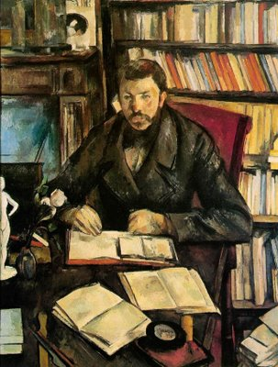
Monday June 5: Departure day – please book afternoon flights so that we can visit one more town this morning…..

Aix en Provence: town of water, town of art – the perfect place to end a tour of Provence

Aix is a small, classically Provençal town, famous for being home to Cezanne. Aix has always been a rich city. It is gorgeous. The city center is mostly pedestrian and, though it is quite small (you can cross the center in 15 minutes by foot), offers plenty to see. As in all Provençal towns, the city center consists of narrow streets, lined with 17th century buildings and paved plazas, and tempting stores.

Kashrut: a mashgiach tmidi represents our Rav Machshir, Rav Oren Duvdevani; glatt meat; chalav stam, but chalav yisrael can be provided, if requested in advance.
Daily Tefillot:(am & pm) with Sefer Torah.
from $8,950pp sharing for 7 days, 6 nights
There are just 12 rooms at this price, first come first served!!

Superior rooms and suites available with supplement
Single occupancy available with supplement

not included in the price of your trip
- Flights
Recommended are as below – other options available – please ask us to research cheapest or with different timetable:

From NY: dep Monday May 29 17.30 to MRS via Paris CDG
Return: dep. Monday June 5 14.45 from MRS via Paris CDG

From TLV: dep Monday May 29 DIRECT EL AL (stay over at airport)
Return: dep. Monday June 5 DIRECT EL AL evening flight

From London LHR: many options May 30, please arrive by 10am
Return: dep. Monday Jun 5 several options

spending money for shopping: plenty to choose from, although we limit the time allocated. However you can always go off on your own and meet us later!!
- upgrades: deluxe rooms (DLX), suites (SUI) and single occupancy are available at an additional price (see booking form).
- insurance: all clients should be aware that while all efforts are made to avoid any problems before during or after your trip, Naomi carries no insurance for your health or luggage. While using the services only of registered suppliers, we recommend that you purchase fully comprehensive travel insurance, to include cancellation, as Naomi cannot be held liable for any mishaps during your stay.
- tips: we recommend $500 per person for the week for drivers, chefs, waiters and chambermaids: we will collect and distribute for you.

Contact details: Eric
info@naomitours.com
www.naomitours.com
++972 (0) 52 3860551

